

Name : Teh Jer Sheng

Login ID : R03412911@oasis-portal.com

Course title : Executive Diploma in Culinary Arts & Hospitality Management

Subject Code : CA03 International Cuisine

Submitted date: **7/September/ 2017**

**Table of Contents**

|  |  |  |
| --- | --- | --- |
| **No** | **Details** | **Page** |
| 1 | Executive Summary | 2 |
| 2 | Introduction | 3 - 4 |
| 3 | Assignment Question |  |
|  | Part 1 | 5 - 15 |
|  | Part 2 | - |
|  | Part 3 | - |
|  | Part 4 | - |
| 4 | Conclusion | 16 |
| 5 | References | 17 |
|  | Appendix | - |

**Executive Summary**

In this assignment we will learn about the purpose of this unit that is to be able to understand International Cuisine within Culinary Arts and Hospitality Management.

We will need to choose one dish from each cuisine. The cuisines are Chinese, Western and Indian cuisine. From each cuisine we will need recreate or alter the original recipe into our own recipe.

Moreover, in this exercise we learn some of the special dishes recipes from different countries. The raw ingredient, spices, cooking method can be different in any region and influence by people life style, weather, religion, historical and etc.

**Introduction**

International cuisine is fusion cuisine. It’s basically mixing elements of regional traditions and means the dish could be a variation such as French, American, Italian, Chinese, Japanese, Korean.

Below some of the example.

French

* Bisque
* Steak frites
* Baguette
* Macaron

American

* American fried rice
* Chicken bog
* Gumbo
* Calas

Italian

* Panzenella
* Focaccia Bread
* Pasta Carbonara
* Tiramisu - The 'pick-me-up' cake

Chinese

* Gong Bao Chicken
* Ma Po Tofu
* Dumplings
* Peking Raosted Duck

Japanese

* Tempura battered and deep fried seafood and vegetables
* Yakitori grilled chicken
* Udon noodles
* Japanese Kaiseki ryori

Korean

* Kimchi
* Bibimbap (combines rice, vegetables and eggs with a spicy sauce)
* Bulgogi
* Samgyetang – Korean ginseng chicken soup

**Assignment Questions**

**Assignment 3**

You should create your own dish from each international cuisine listed.

Required:

Choose one dish for each cuisine:

(i) Chinese cuisine

(ii) Indian Cuisine

(iii) Western Cuisine

You should be able create own recipes.

1. **Chinese cuisine**

**Sweet and sour pork**

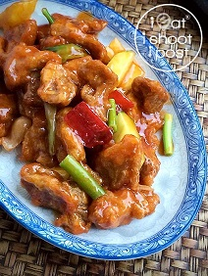

I love sweet and sour pork. In fact, I think it is probably one of the top 3 most popular dishes amongst Singaporeans. Every economical rice stall will have this dish in one of their trays and you should be able to order it at every Cze Char stall.The great thing about this dish is that you can easily make it at home. You don’t require a super hot wok to make it as you would Hor Fun. This is one of the dishes that we have at home at least twice a month. The great thing about making this yourself is that you can actually taste the pork which will be juicy and bouncy encased by a crisp shell, Most of the time when you have this outside, its like just eating sweet and sour batter!

**Ingredients**

1. Pork

500g Pork Collar

1/3 tsp bicarbonate of soda

1 tsp salt

1/2 tsp MSG

1 Tbsp water

2 eggs

3 Tbsp custard powder (can substitute with corn flour)

B1. Sweet and Sour ingredients

2 Tomatoes

1 Red chilli (de-seeded)

1 Cucumber

80g Pineapple

3 Stalks spring onions

B2. Cucumber Marinade

1 Tbsp White vinegar

2 Tbsp Water

1/2 Tbsp sugar

B3. Sweet and Sour Sauce

8 Tbl water

1 1/2 Tbsp White vinegar

2 1/2 Tbsp Tomato sauce

1 1/2 tsp chilli sauce

1/2 tsp Maggie seasoning sauce

4 1/2 Tbsp sugar

1/2 tsp MSG

2 tsp Light soya sauce

1/2 tsp Sesame sauce

1 Tbsp Custard powder

**Method**

1. Cut pork into bite sized cubes (8g). Add the rest of the ingredients in A except custard powder and mix thoroughly. Add custard powder and mix. Marinade for 1 hour.

2. Cut cucumber lengthwise into 3 portions and remove core. Then cut into thin strips and marinade with ingredients from B2 for 3 hours. Drain before frying.

3. Deep fry the pork in 170°C oil. Make sure to fry in small batches so that the oil temperature does not drop. Fry for approx 3 mins or until crispy and slightly brown. Place on rack or absorbent paper to drain off the oil.

4. To make the sauce, dissolve custard powder in water and then add it to the rest of the ingredients in B3.

5. Heat wok then lower heat and add 1 Tbsp oil. Add ingredients in B1 and stir fry for 1 min. Add the sauce from step 4 and bring to boil and simmer to thicken. Add deep fried pork, turn off the heat and toss to mix thoroughly and serve.

**My recipes**

**Honey starfruit pork**

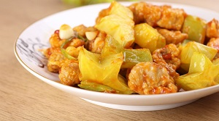

**Ingredients**

300g pork collar

1 starfruit

30g onion

30g ginger

1 garlic

3 sp potato starch

2 sp

½ tsp salt

¼ tsp white pepper

¼ tsp black pepper

1 egg

3 sp honey

1 sp tomato sauce

½ lemon

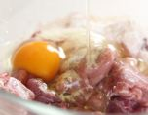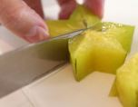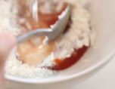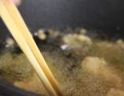

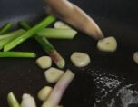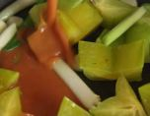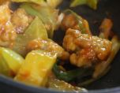

1. **Indian Cuisine**

**Butter chicken**

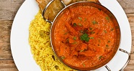

**Ingredients of Butter Chicken**

For the Marination

400 to 500 grams of chicken

½ to ¾ tsp red chili powder

1tsp ginger garlic paste

Salt as needed

1 to 2 tsb yogurt

½ to ¾ tsp garam masala

Little turmeric

**Ingredient for gravy**

1tbsp butter or oil

1 cups cubed onion, 3 medium

1.5 cups finely chopped deseeded tomatoes (3 large)

Salt as needed

10 to 12 cashew nuts / kaju

½ to ¾ tsp garam masala powder

½ to ¾ tsp Kashmiri red chili powder

1 tsp coriander powder

½ tsp sugar (optional)

1 ½ tbsp. butter

1 bay leaf

3 green cardamom

2 to 3 cloves

1 small cinnamon stick

1.5 tsp kasuri methi

3 tbsp cream (for restaurant style)

Few coriander leaves for garnish

**Method**

1. Marinate chicken with ingredients mentioned under marination. Set aside till we need it. Overnight marination is needed to yield restaurant style dish.
2. Heat 1 tbsp butter or in a pan, fry onions till the raw smell goes away
3. Saute tomatoes with salt.
4. Add chili powder, garam masala powder and coriander powder along with cashews.saute until the raw smell goes away.
5. Cool and blend together with ¾ to 1 cup water.

**Making butter chicken masala :**

1. Heat the pan with more butter and fry cinnamon, cloves, bay leaf and cardamom.
2. Add ginger garlic paste and fry till the raw smell goes off.
3. Add marinated chicken and sauté on a medium high until the masala dries up.
4. Pour the onion tomato puree, adjust as needed chili powder and masala powder.Also adjust the consistency of gravy by addingmore water if needed.
5. Cook until the chicken turns tender.
6. Add kasuri methi and stir.
7. Add cream and stir well.You can skip cream if using little more of cashews to the puree.
8. Add chopped coriander leaves.
9. Serve Indian butter chicken masala with roti, butter naan or jeera rice.

**My recipe**

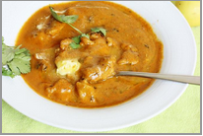

500 gm raw pork

**For the Marinade:**

1 tsp red chilli powder

1 tsp ginger and garlic paste

Salt to taste

1/2 kg curd

**For the Gravy:**

175 gm white butter

1/2 tsp black cumin seeds

1/2 kg tomato, pureed

1/2 tsp sugar

1 tsp red chilli powder

Salt to taste

100 gm fresh cream

4 green chillies, sliced

1/2 tsp fenugreek leaves, crushed

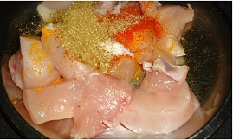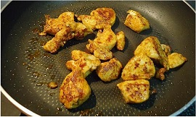

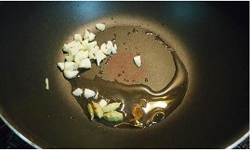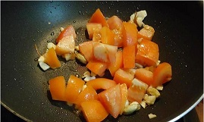

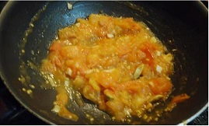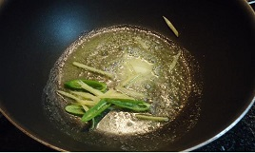

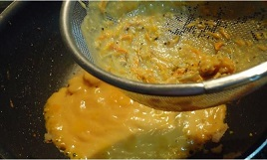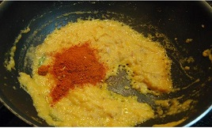

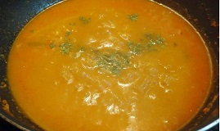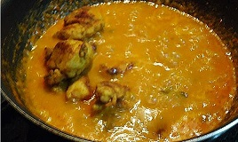

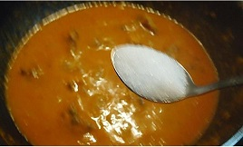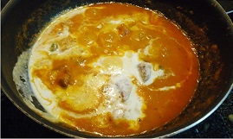

1. **Western Cuisine**

**Macaroni with simple tomato sauce**

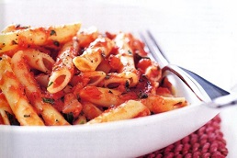

**Ingredients :**

1 tablespoon olive oil

1 brown onion, chopped

2 garlic cloves, crushed

1 x 800g can Italian diced tomatoes

1 tablespoon tomato paste

1/3 cup chopped fresh continental parsley

1/2 teaspoon caster sugar

Salt & freshly ground black pepper

400g Barilla Penne Rigate

**Method :**

Step 1 - Heat the oil in a large frying pan over medium heat. Add the onion and cook, uncovered, stirring often, for 3 minutes or until it softens slightly. Add the garlic and cook, stirring, for 1 minute or until aromatic.

Step 2 - Stir in the tomatoes and tomato paste. Increase heat to high and bring to the boil. Reduce heat to medium and simmer, uncovered, stirring often, for 6-7 minutes or until the sauce reduces and thickens slightly.

Step 3 - Stir in the parsley and sugar. Taste and season with salt and pepper.

Step 4 - Meanwhile, cook the pasta in a large saucepan of salted boiling water following packet directions or until al dente. Drain and return to the pan.

Step 5 - Add the sauce to the pasta and toss to combine. Serve immediately.

**My recipe**

Macaroni & cheese

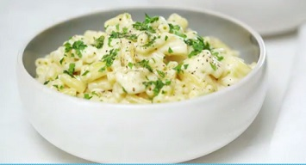

**Ingredients :**

400g macaroni

50g butter

2 tablespoons plain flour

2 cups (500ml) milk

2 cups (250g) grated cheese (gruyere, tasty, vintage)

Chopped parsley, to serve

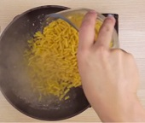  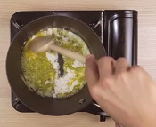**** 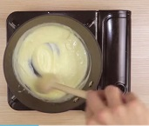 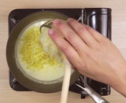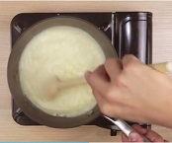 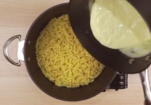 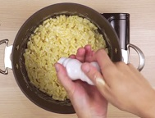

**Method :**

1. Cook the macaroni in a large pan of boiling water according to packet instructions (different brands may vary in size & cooking times) until al dente.
2. Meanwhile, melt the butter in a medium saucepan and add the flour. Cook, stirring, for 1 minute over medium-low heat.
3. Gradually add the milk, stirring until smooth. Stir gently until the mixture comes just to the boil, then reduce heat and simmer for 2 minutes. Remove from the heat, add the grated cheese and stir until melted and smooth.
4. Drain pasta and return to the pan. Pour cheese sauce over the pasta and stir until well coated. Season with salt and white pepper to taste. Serve immediately sprinkled with chopped parsley.

**Conclusion**

In this unit we learn about what is international cuisine and some international cuisine from many different country. International Cuisine provides comprehensive coverage of cuisine found throughout the world not only through recipes and techniques, but also through coverage of the history, culture, geography, religion, and locally grown ingredients that influence these various cuisines. An international cuisine is a cuisine that is practice around the world. A cuisine is a characteristic style of cooking practices and traditions, often associated with a specific region, country or culture. To become an international cuisine, must spread around the world, its food served worldwide. Tourists traveling promotes international cuisine as they demand the similar to at home and immigration also promotes international cuisine as it makes them feel more at home.

**References**

Unknown Author, Unknown date. Online source, Sweet and Sour Chicken; <https://www.pinterest.com/pin/238831586472058731/>

Marzia [Little Spice Jar], Unknown date, Online source, Finger Lickin ‘Butter Chicken (Murgh Makhani); <https://www.pinterest.com/pin/91127592440557989/>

Mel’s Kitchen Café, Unknown date, Online source, Red Brie Pasta Sauce; <https://www.pinterest.com/pin/498984833684247800/>

NDTV Food Desk, September 01 2017, Online source, 10 Best Italian Food Recipes; <http://food.ndtv.com/lists/10-best-italian-recipes-699798>

Dora Mekouar, MAY 18 2015, Online source, Top 10 Most Popular Ethnic Cuisines in US; <https://blogs.voanews.com/all-about-america/2015/05/18/top-10-most-popular-ethnic-cuisines-in-us/>